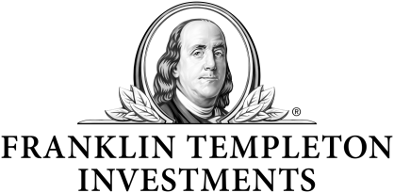 | Build a Better Retirement
Is your investment strategy ready  for the changes that retirement brings?  RetireMetrics® is designed to help you better understand  and prepare your portfolio for retirement. RetireMetrics uses  measures that can help go deeper into examining a fund’s potential to help meet the unique challenges of financial  planning for your retirement.  Join our presentation to learn how RetireMetrics can help answer these key questions:  1. How do I find investments that match my risk tolerance level?  2. Am I diversified or simply duplicating funds in my portfolio?  3. Is there a way I can estimate my portfolio’s chances of sustaining retirement income over time?
  Hosted By:
  [Place Name and Surname]
  Firm:
  [Place Firm's Name]
  Date:
  [Place date here]
  Time:
  [Place time here]
  Place:
  [Investment Place Lecture Hall,]
  [3rd Floor 1234 Main Street] [Anywhere, USA 45612]
  To RSVP:
  Please contact [Advisor Name]
  at [Advisor Phone Number]
  or [Advisor Email]
  Attendance is limited.
This communication is general in nature and provided for educational and informational purposes only. It should not be considered or relied upon as legal, tax or investment advice or an investment recommendation, or as a substitute for legal or tax counsel. Any investment products or services named herein are for illustrative purposes only, and should not be considered an offer to buy or sell, or an investment recommendation for, any specific security, strategy or investment product or service. Always consult a qualified professional or your own independent financial advisor for personalized advice or investment recommendations tailored to your specific goals, individual situation, and risk tolerance.
Franklin Templeton does not provide legal or tax advice. Federal and state laws and regulations are complex and subject to change, which can materially impact your results Franklin Templeton Distributors, Inc. (FTDI) cannot guarantee that such information is accurate, complete or timely; and disclaims any liability arising out of your use of, or any tax position taken in reliance on, such information.
All financial decisions and investments involve risk, including possible loss of principal.
RetireMetrics is a retirement planning tool and its use does not guarantee that you will have sufficient funds to meet future retirement needs. This workshop is being provided for educational and informational purposes only and is not intended to provide investment or tax advice. Investors should consult with their appropriate tax, legal and financial advisors with respect to their individual circumstances.
Franklin Templeton Distributors, Inc., One Franklin Parkway, San Mateo, CA
Not FDIC Insured | May Lose Value | No Bank Guarantee | © 2018 Franklin Templeton Investments. All rights reserved.
 | RRET RMINV 06/18

